Big Mountain Resort Project Report (Draft)

From the Model 3 in GuidedCapstoneStep5HL(<https://colab.research.google.com/drive/1uGx8XYNMfAafaCaJ19Ds_6xZjubIpoeI#scrollTo=x7-bOQNK_Jy8>)

I have no idea what does the Coeffcient means and how to interpret it? Is it the larger coefficient means that the variable has bigger impact of the AdultWeekend ticket price?

Coefficient

AdultWeekday 10.472130

vertical_drop 2.451226

TerrainParks 2.183509

LongestRun_mi 2.077653

SkiableTerrain_ac 2.051704

projectedDaysOpen 1.948651

daysOpenLastYear 1.932328

quad 1.823765

surface 1.328674

double 1.166103

From GuidedCapstoneStep6HL (<https://colab.research.google.com/drive/13duEztKpdfKWsegVeyMZDKzpLeT21kiI#scrollTo=oWH_q9YOGUY5>)

We saw the predict is really not correct at all, I think this linear regression model wasn’t a good model to predict the price at all:

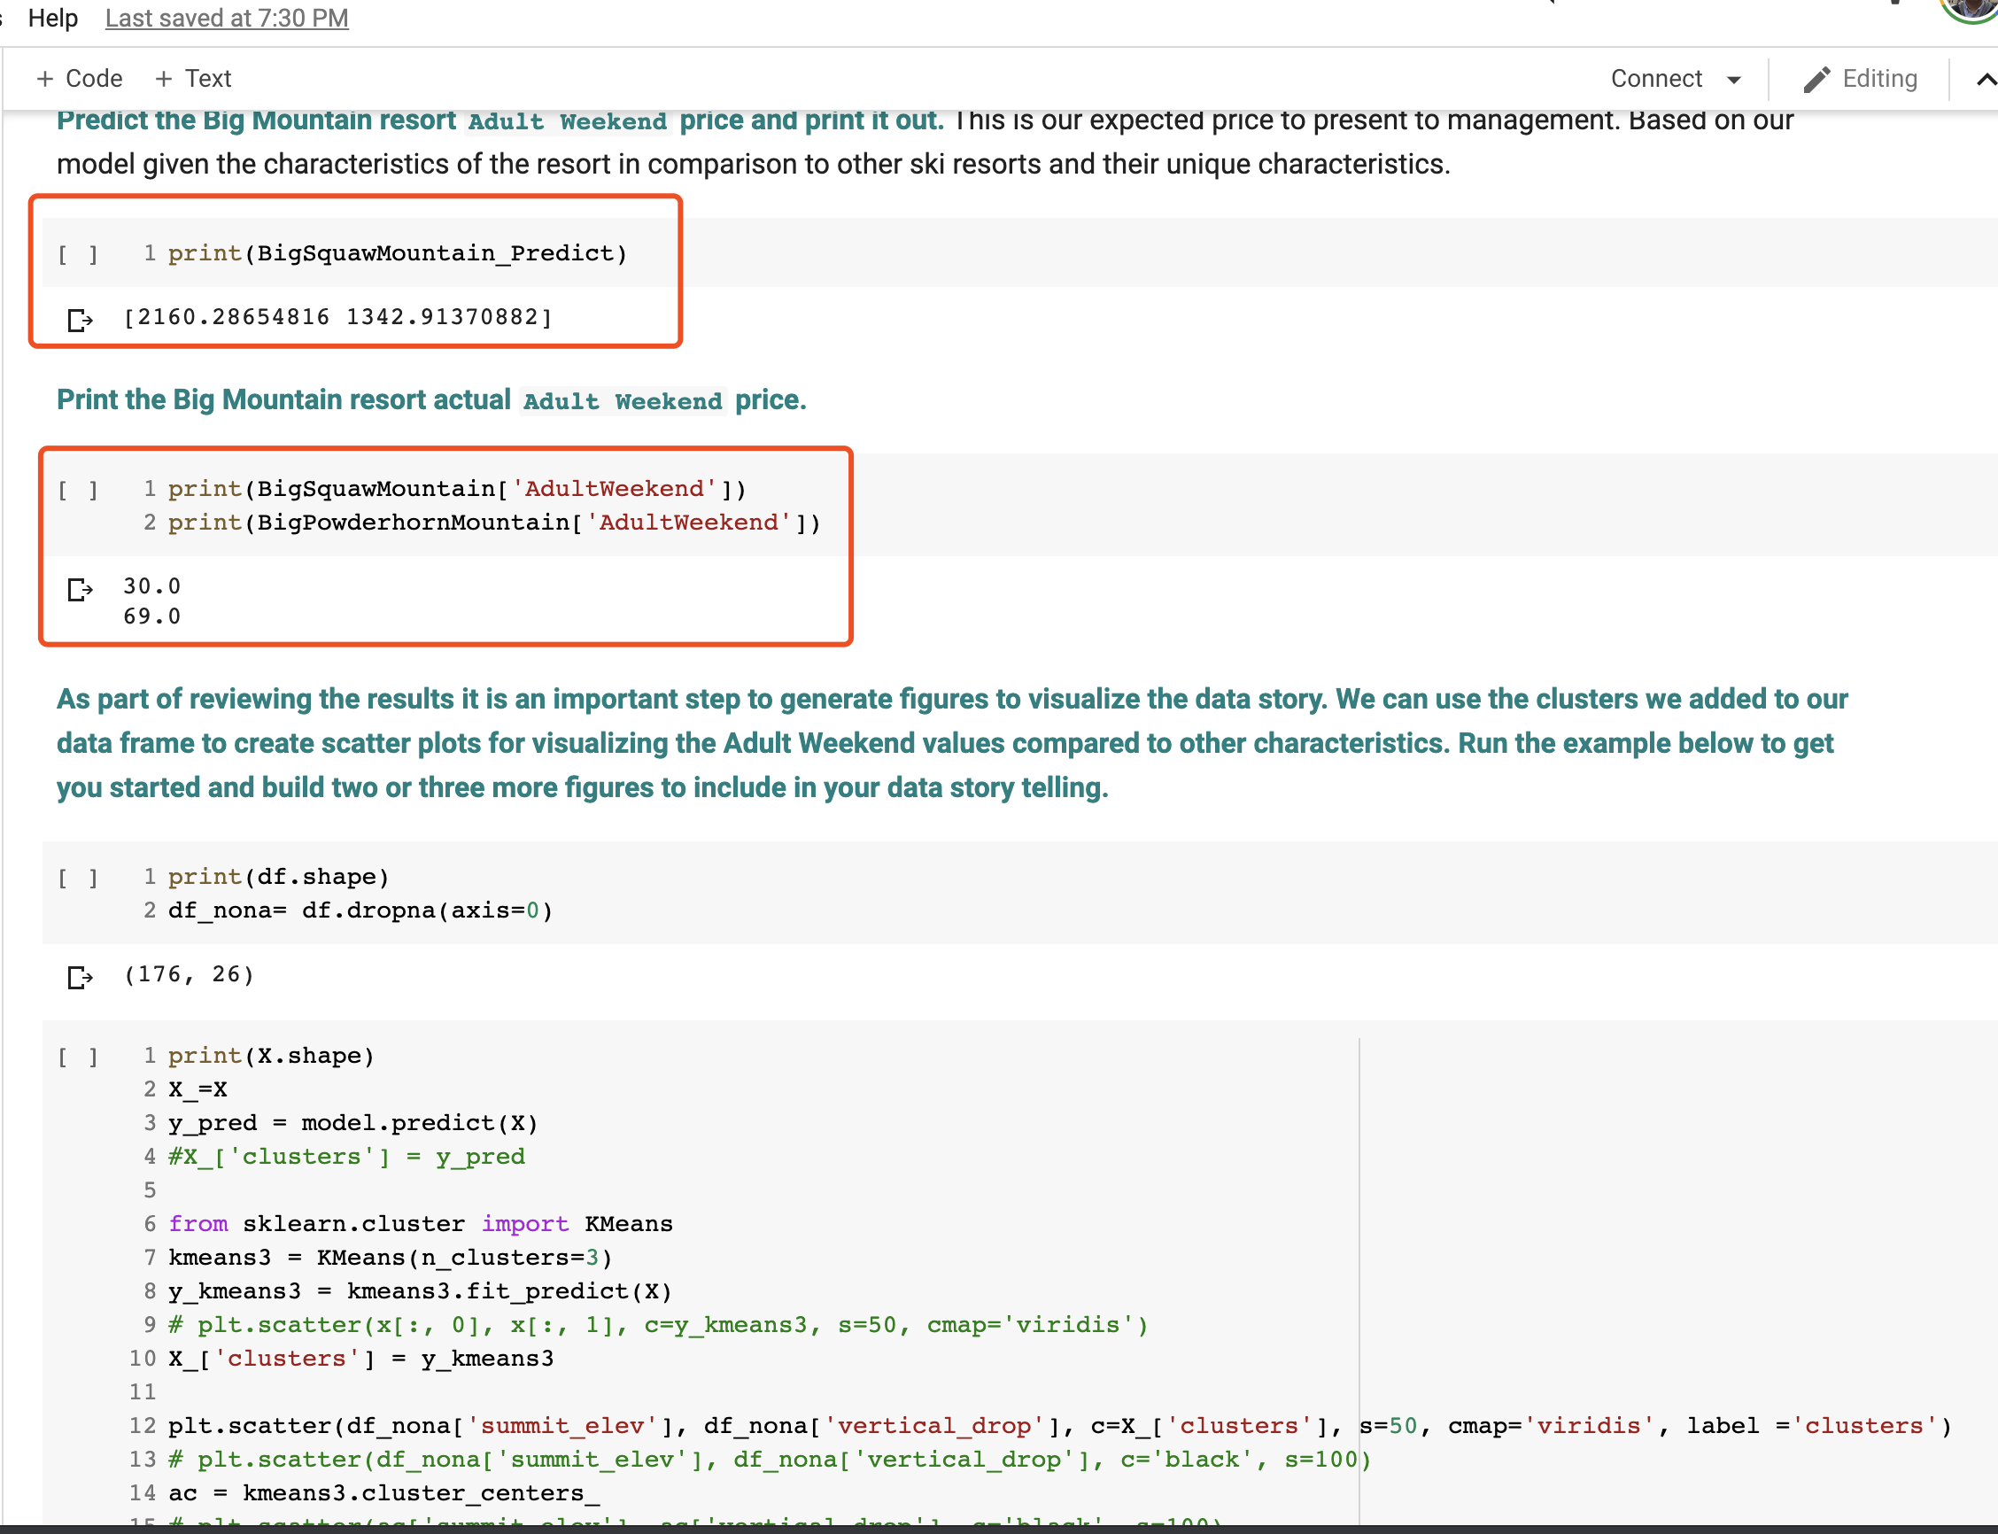

Also no idea what is the following cluster scatter chart mean and how to interpret it.

